

Ethical Hacking for Security Fortification
With Ettercap

Rui Zhao, CCNA
Purpose:

The purpose of this lab is to utilize Ettercap, for educational purposes, to investigate man-in-the-middle attacks and ARP poisoning and configuring port-security to mitigate the damages provided by Ettercap.

Background:

Ettercap’s unorthodox origins tracked back in 2001 when a pair of Italian programmers decided to code a network security breach tool specialized for man-in-the-middle attacks to eavesdrop and sniff passwords. This program wasn’t restrictive, as it’s free and open sourced, offering hackers, ethical or not, opportunities to experiment with Ettercap’s security breaching opportunities at no price.
The ability of Ettercap was so powerful that instead of arresting the authors, Alberto Ornaghi and Marco Valleri, of the program, the Milan police department decided Ettercap would instead be a perfect opportunity for police to spy and audit on the target’s Skype calls. With this trajectory, the Ettercap company began to commercialize in selling hacking software to law enforcements.
The capabilities of Ettercap would only expand as time progresses as tools such as ARP poisoning, DOS attacks, fingerprints, spoofed DNS replies, isolating hosts from LAN, smurf attacks, and even becoming a root of a switch spanning tree became an option under the Ettercap client. Furthermore, additional plugins could be employed inside Ettercap.
Furthermore, Ettercap are IP, MAC, ARP, and PublicARP based, meaning it has four flexible modes of operation. These features would be expanded as Ettercap also supports multiple other features such as DNS hijacking, HTTPS support (sniffing through HTTPS’s secured data, even if connection is through a proxy), and Password collection.
Security wise, Ettercap is a phenomenal tool to experimentally attack your network to identify vulnerabilities. Cybersecurity professionals often use Ettercap as a way to fortify network security and prevent future breaches of sensitive data. Ethical consideration for whether Ettercap should exist as a deployment of unrestricted program has been controversial, but it nonetheless serves as a prominent tool that offers both the benefits and the disadvantages.
A dependency of the Ettercap installation however is Kali Linux, which is a specialized Debian-based Linux operating system (by Offensive Security, or Offsec) developed and designed for Cybersecurity practices like penetration testing, security auditing, digital forensics, and reverse engineering. Kali Linux has taken the Cybersecurity professionals by storm, gaining popularity through its tools and capabilities. The installation of the Kali Linux operating system has certain requirements. Kali Linux requires: 20GB+ hard disk space (for installation), 128MB+ of RAM (2 GB if using XFce4 interface) and USB stick (or CD-DVD drive).
Moreover, on Kali Linux, the default shell was switched from Bash to ZSH (though Bash can still be used). It’s also equipped with 600+ pre-installed security, not limited for vulnerability analysis, wireless attacks, password attacks, exploitation, etc. Kali Linux is legal to install and use, but using illegal tools without authorization can be illegal and unethical. The operating system is strictly intended for authorized testing and educational purposes for the Cybersecurity sector.

Lab Commands:

Setting up Kali Linux (recommended)

To run the Ettercap application, it’s recommended to be mobilized with the Kali Linux operating system with Cybersecurity tools. Kali Linux supports many Cybersecurity systems, which include Ettercap. Optionally, you can also run Kali Linux with virtual machines. NOTE: You need a USB flash drive with a minimum capacity of 8 GB (16-32GB recommended) to install the standard Kali Linux ISO to ensure space for operating system and essential tools.

Head over to https://www.kali.org/ and download Kali Linux ISO image.

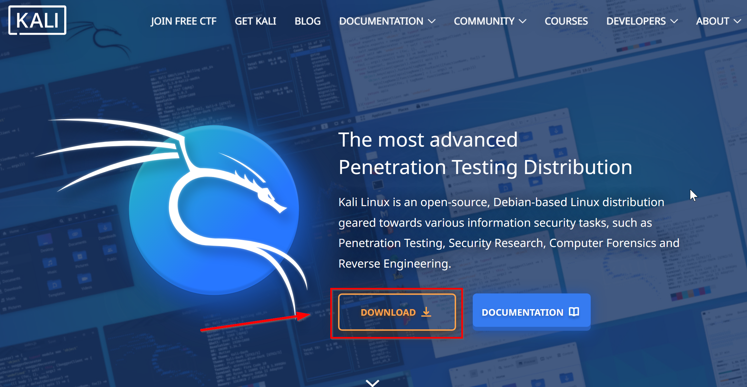

Depending on if you are going to utilize a virtual machine or if you are installing an ISO image, click on which one you desire.

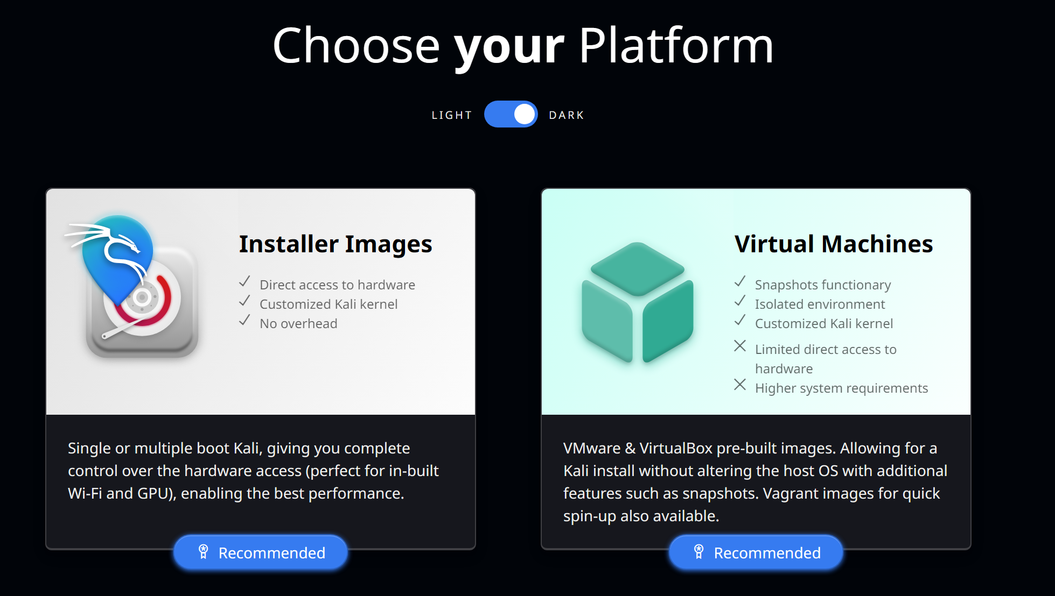

We’ll proceed with the Image Installation. After pressing Installer Images, proceed down to the Kali Linux Installer and click install. NOTE: You should have your 8GB+ USB stick plugged in at this point.

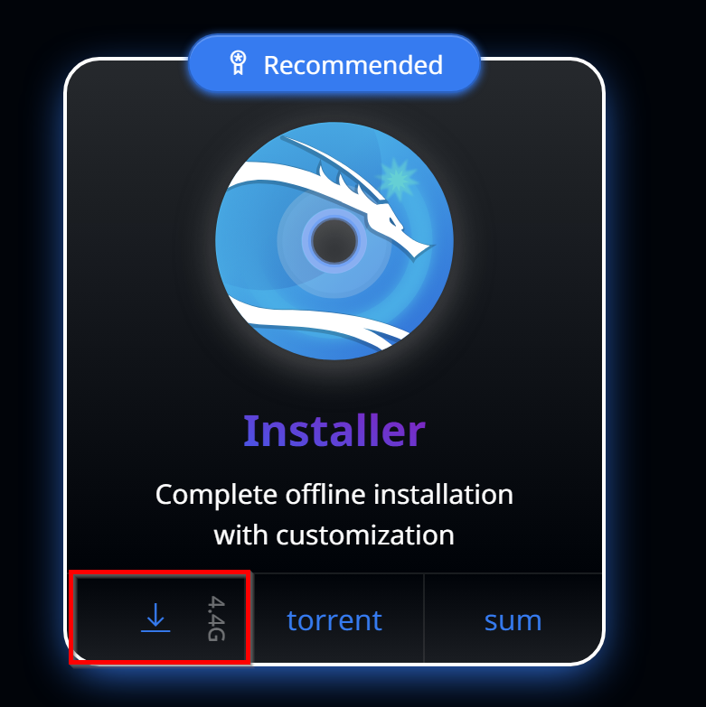

Head over to https://rufus.ie/ to download the Rufus dependency for the ISO image installation process.

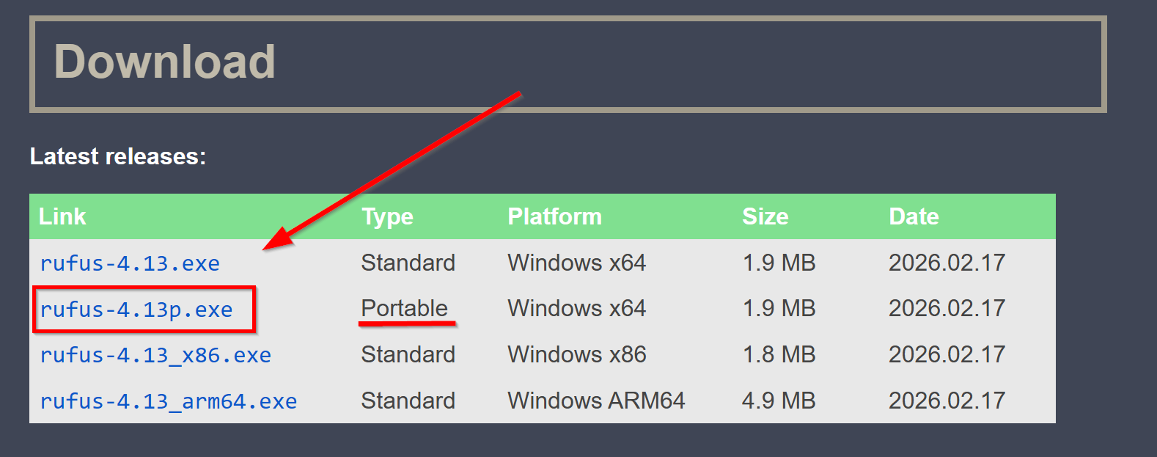

Open up rufus-4.13p.exe from File Explorer

Once in, copy these settings and start Rufus. However, do note, this will wipe your USB drive out completely, so back important information if it exists in the USB drive.

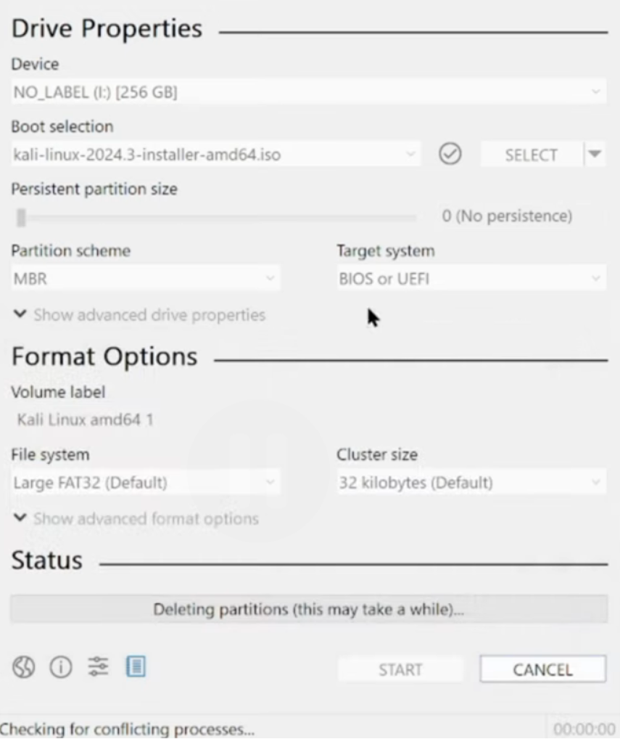

Then reboot your machine with USB drive still plugged in. When you are in boot screen, enter boot mode. For Dell/Acer/Lenovo, it will be F12. For HP. It will be F9. For ASUS, it will be F8 or ESC. For other devices, tab ESC, F1-12, or Enter during bootup.

Select your USB Flash Drive in this menu with arrow keys and press Enter.

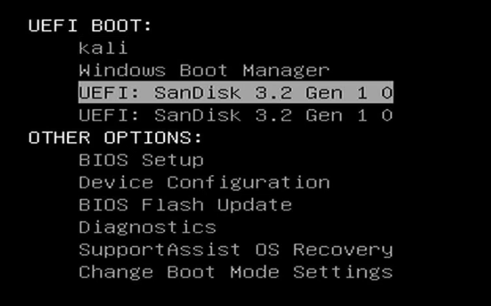

You’ll know it is working when you are greeted with a screen like this:

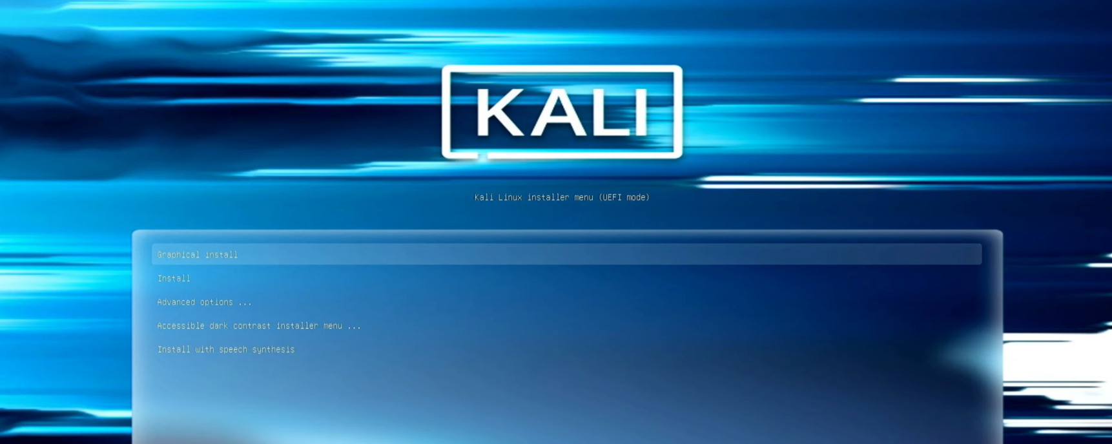

Next, follow the steps offered by the Kali Linux startup to set up your environment. After successful configurations, you should be booted up in the Kali Linux environment. Enter your login credentials and press Log In.

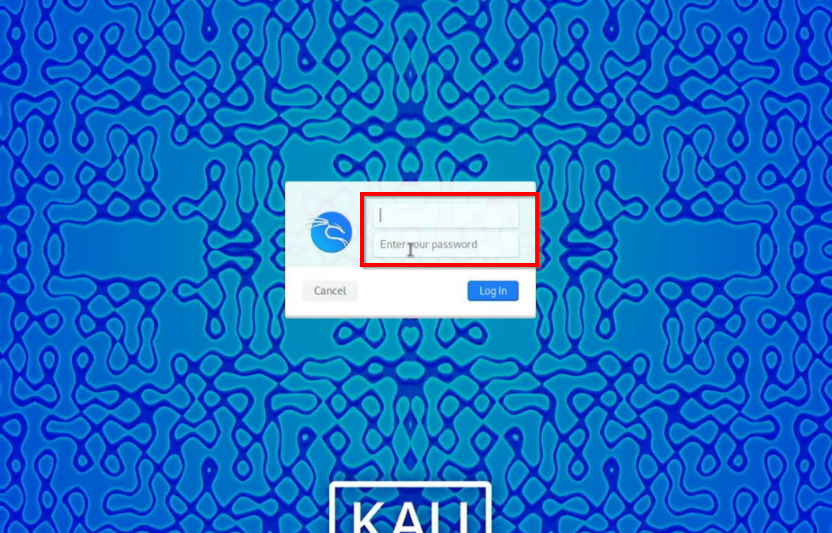

Congratulations, you have set up Kali Linux for Cybersecurity Research.

Entering and Using Ettercap:

Enter Ettercap with the console with sudo Ettercap -G

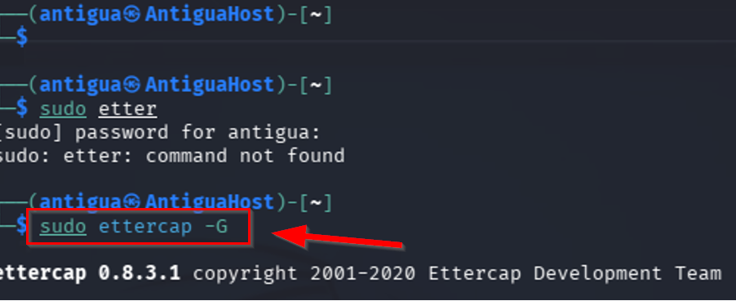

Alternatively, you can enter Ettercap with Ettercap-pkexec if installed.

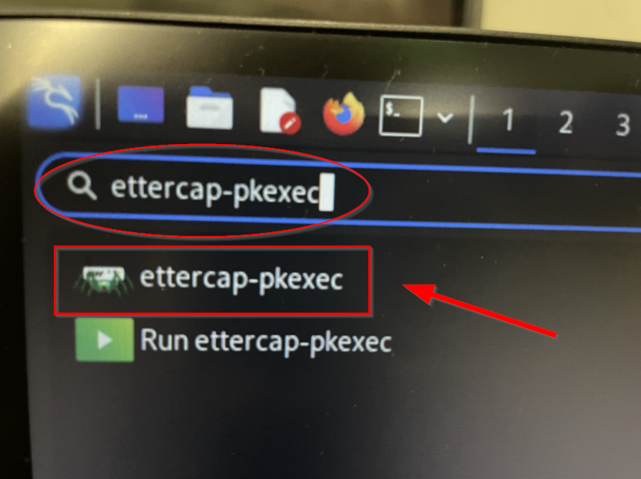

Once inside Ettercap, click on the checkmark on the upper right to begin unified sniffing.

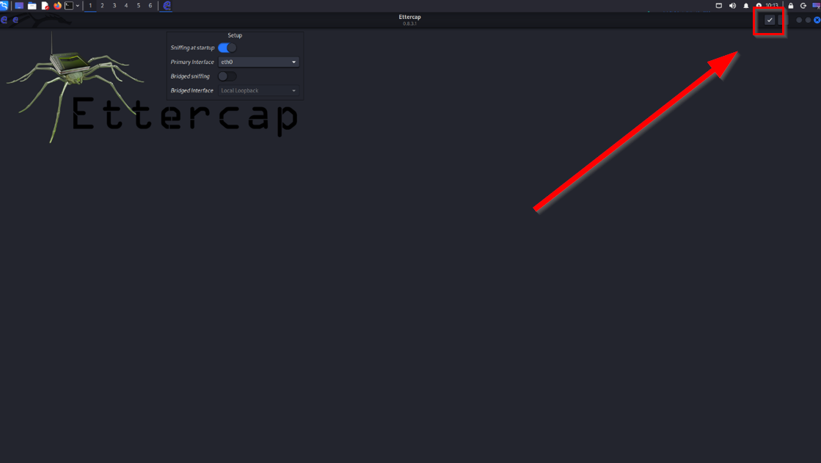

Note: you would know it is working when the bottom console indicates that unified sniffing has been started.
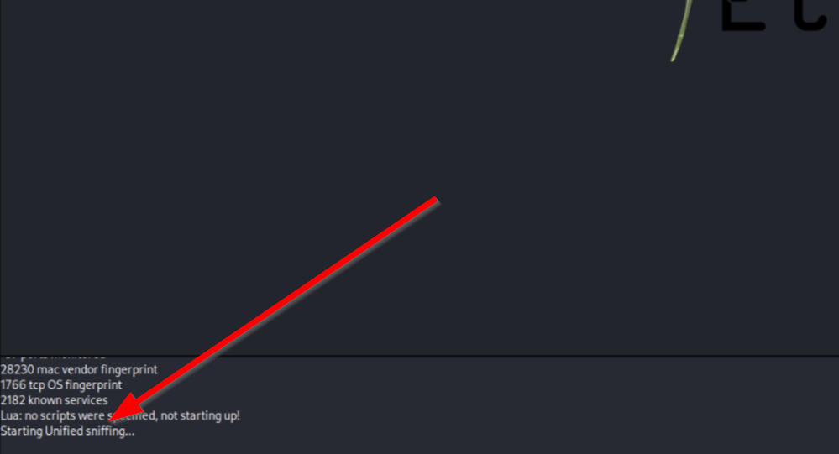

Mac Flooding:

On the top right, navigate and press the three dots and press plugins.

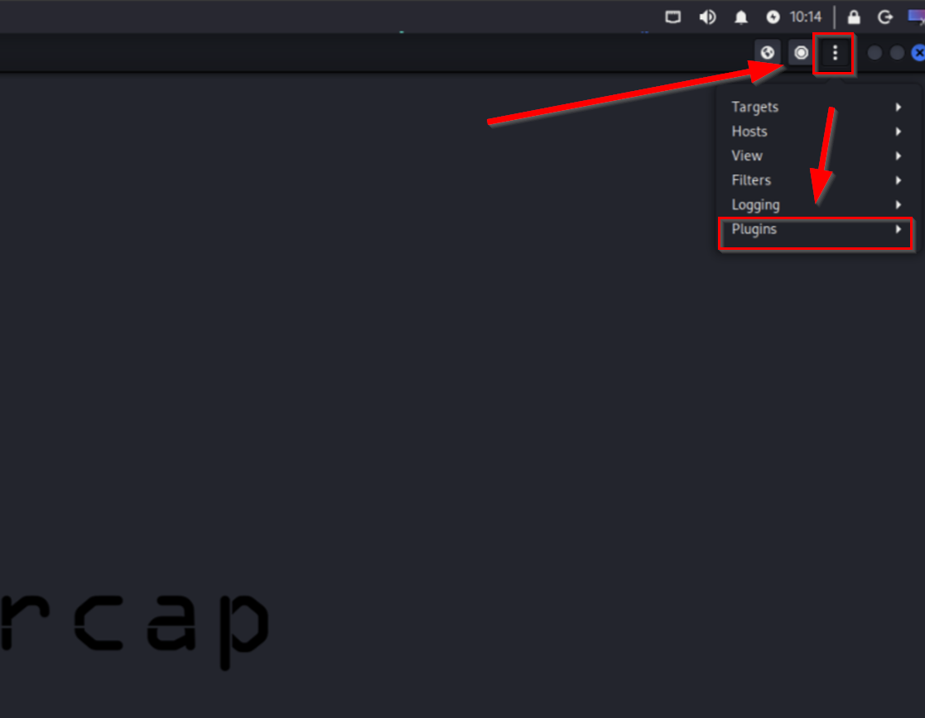

Then, click on manage plugins to access the list of commands you can do.

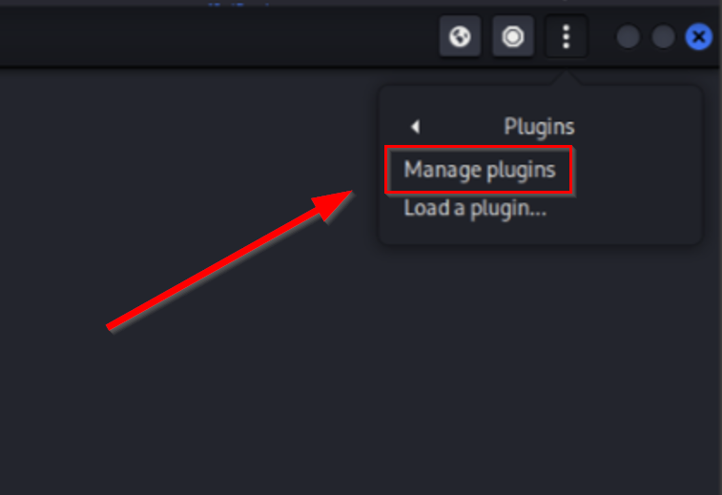

Here are all of the attacks and actions you can employ with Ettercap,

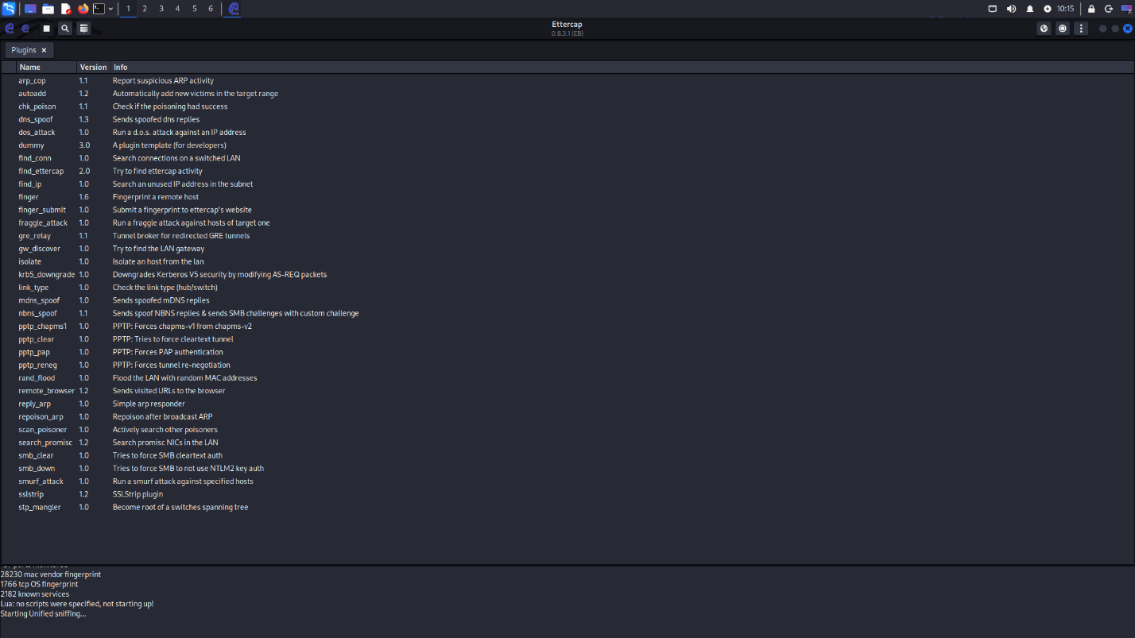
To run MAC flooding, we can select the rand_flood feature by Ettercap to flood the LAN with random MAC addresses.
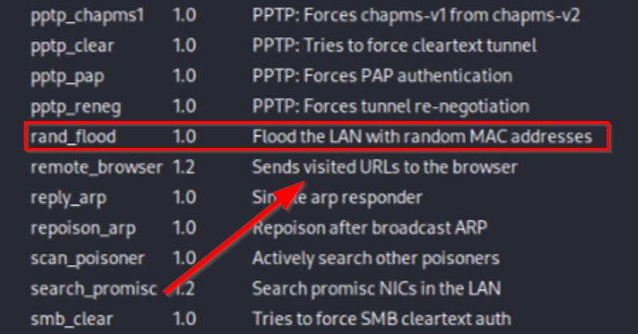

Once that has started, thousands of random MAC addresses will be forwarded. Optionally, you can view this happening with Wireshark.

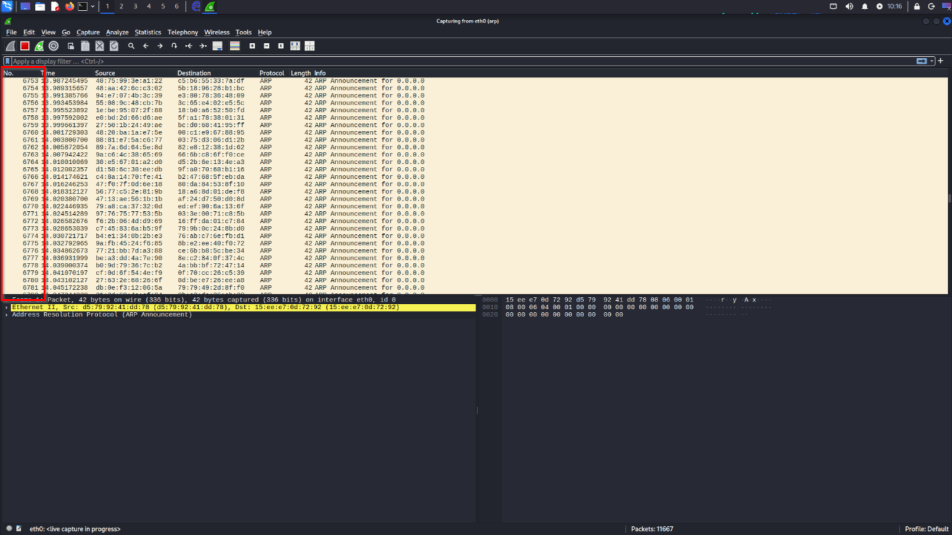

As evident, tens of thousands of MAC address announcements are deployed onto the switch, which flooded our switch. We’ll be implementing port-security protocol to mitigate this problem later in the demonstration lab.

ARP Poisoning:

Next up, in order to run ARP Poisoning into the network, we need to configure our targets to employ ARP poisoning attack on. Select your host to target ARP poisoning. For this example, we would be using the targets of 192.168.1.1 and 192.168.1.2.
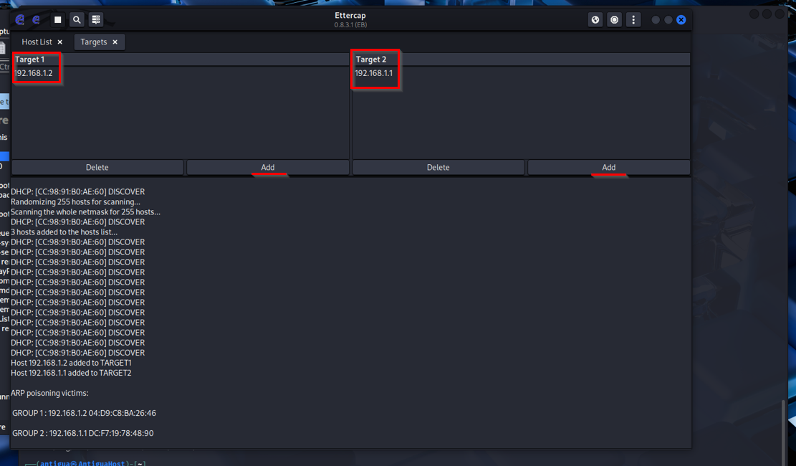

Click on the three dots and navigate to ARP poisoning.

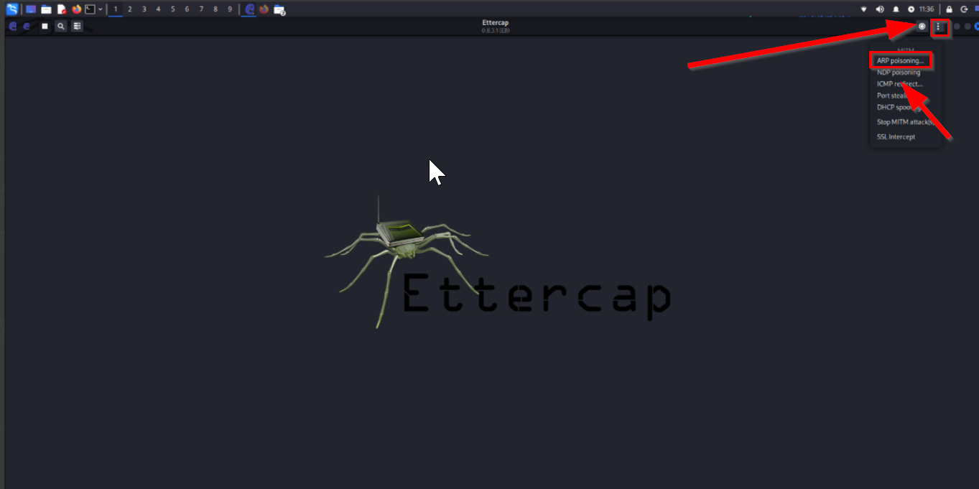

Next up, configure the settings for ARP Poisoning. For this example, we will be sniffing remote connections and disabling poisoning one-way.
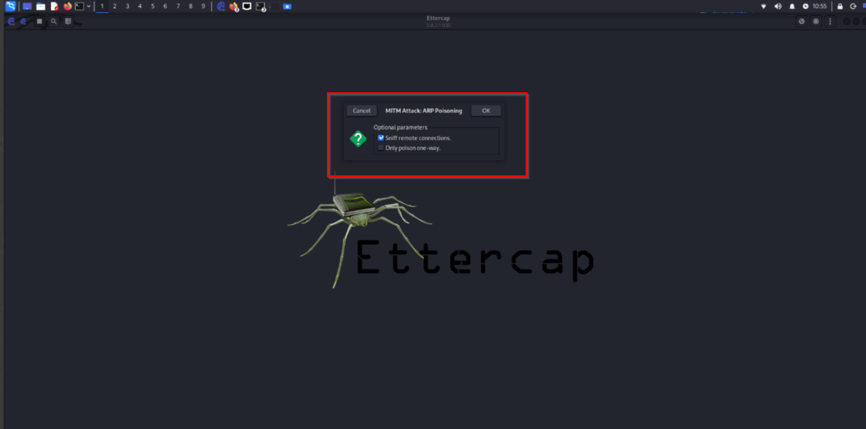

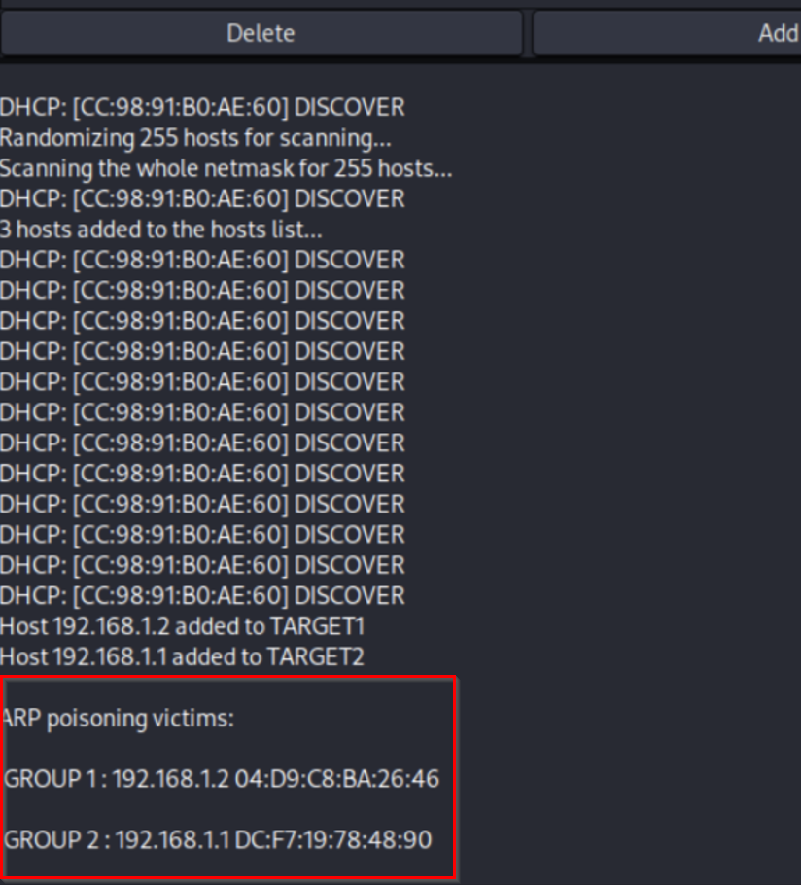

After that is started, you should start to run ARP poisoning. To check ARP poisoning status, head over to navigate back to plugins and select chk_poison.

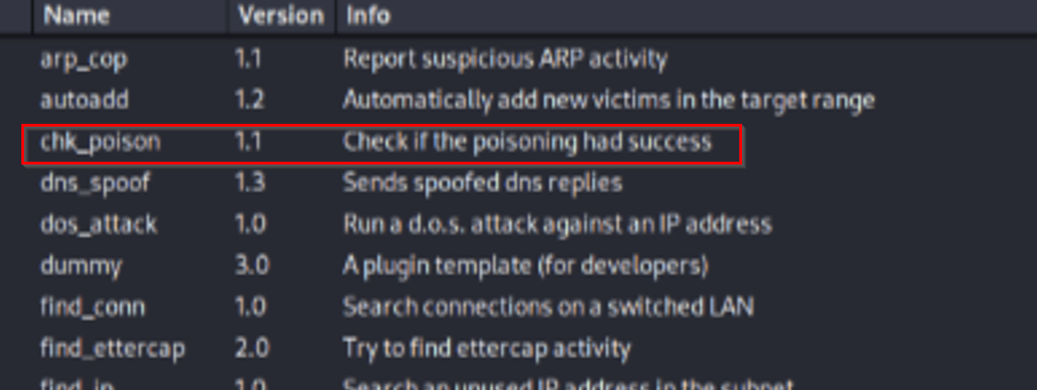

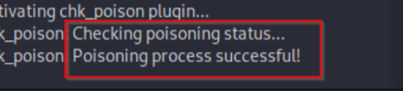

Alternatively, as a Man-In-The-Middle attack, you can view this happening in Wireshark where a duplicate use of 192.168.1.2 is detected. This means the attacker is intercepting network devices by impersonating 192.168.1.2 address to read their traffic.

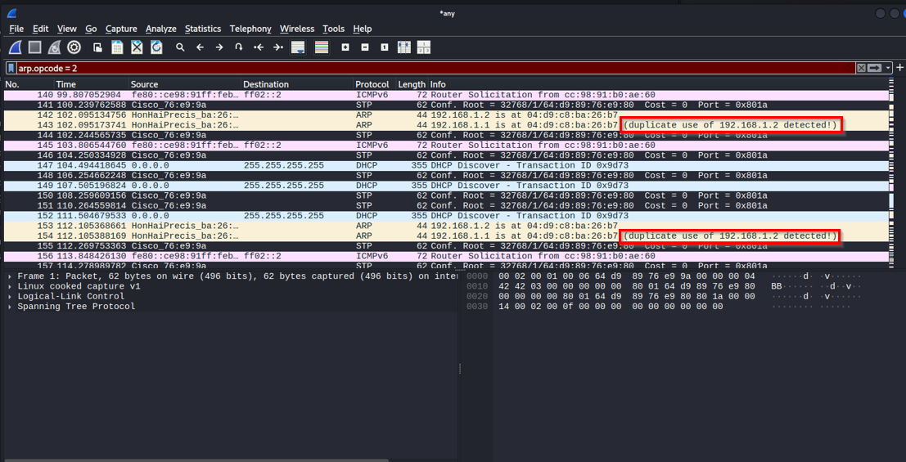

Congratulations, you have successfully ran a Man in the Middle Attack, also known as ARP Poisoning! In order to protect against these attacks, we should configure port-security.

Configuring Port Security

Here’s what MAC Flooding will do to your switch without port-security.

Before flooding:

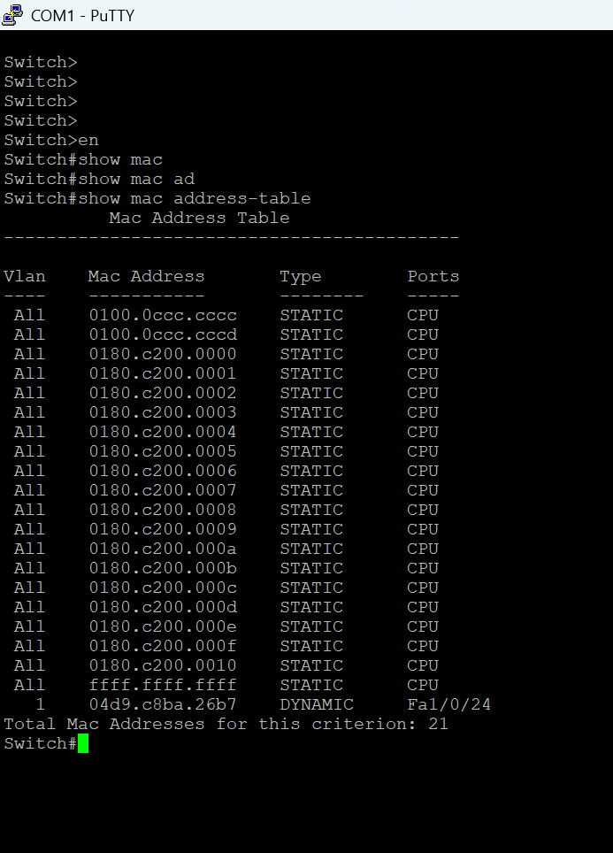

After flooding:

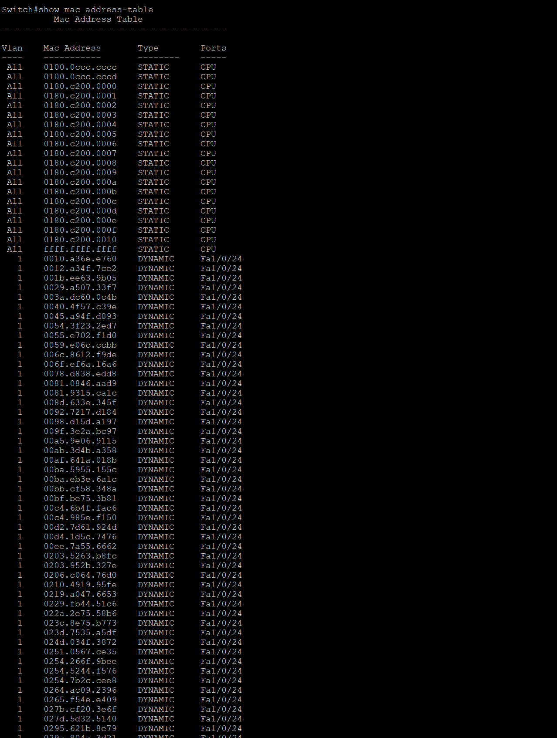

As you can see, it is evident that without port-security configured, the entire mac address table is completely flooded. This would make the victim’s switch act as a hub and forwards traffic to all ports. This is dangerous because attackers could intercept (sniff) private data and cause network disruptions.

To configure port security, console into the switch and input these commands.

Switch#conf t
Enter configuration commands, one per line. End with CNTL/Z.
Switch(config)#int range f1/0/#-#
Switch(config-if-range)#switchport mode access
Switch(config-if-range)#switchport port-security maximum 2
Switch(config-if-range)#exit
Switch(config)#int range f1/0/#-#
Switch(config-if-range)#switchport mode access
Switch(config-if-range)#switchport port-security
Switch(config-if-range)#switchport port-security maximum 2
Switch(config-if-range)#switchport port-security mac-address sticky
Switch(config-if-range)#exit
Switch(config)#
Switch(config)#exit
Switch#

What these commands do is configure port-security onto your switch. Additionally, it would only have a maximum of 2 (adjustable) mac addresses present at once, and is configured to learn them dynamically. To verify that you have configured this correctly, issue Switch# show run and scroll down to your interfaces configured with port-security. It should look like this:

Example configured for interfaces F1/0/23-24

interface FastEthernet1/0/23
switchport mode access
switchport port-security maximum 2
switchport port-security
switchport port-security mac-address sticky
!
interface FastEthernet1/0/24
switchport mode access
switchport port-security maximum 2
switchport port-security
switchport port-security mac-address sticky
Since the mac-address table is now limited to only two mac-addresses, all other mac-address entries will be discarded.

Here is the MAC address table after flooding with port-security:

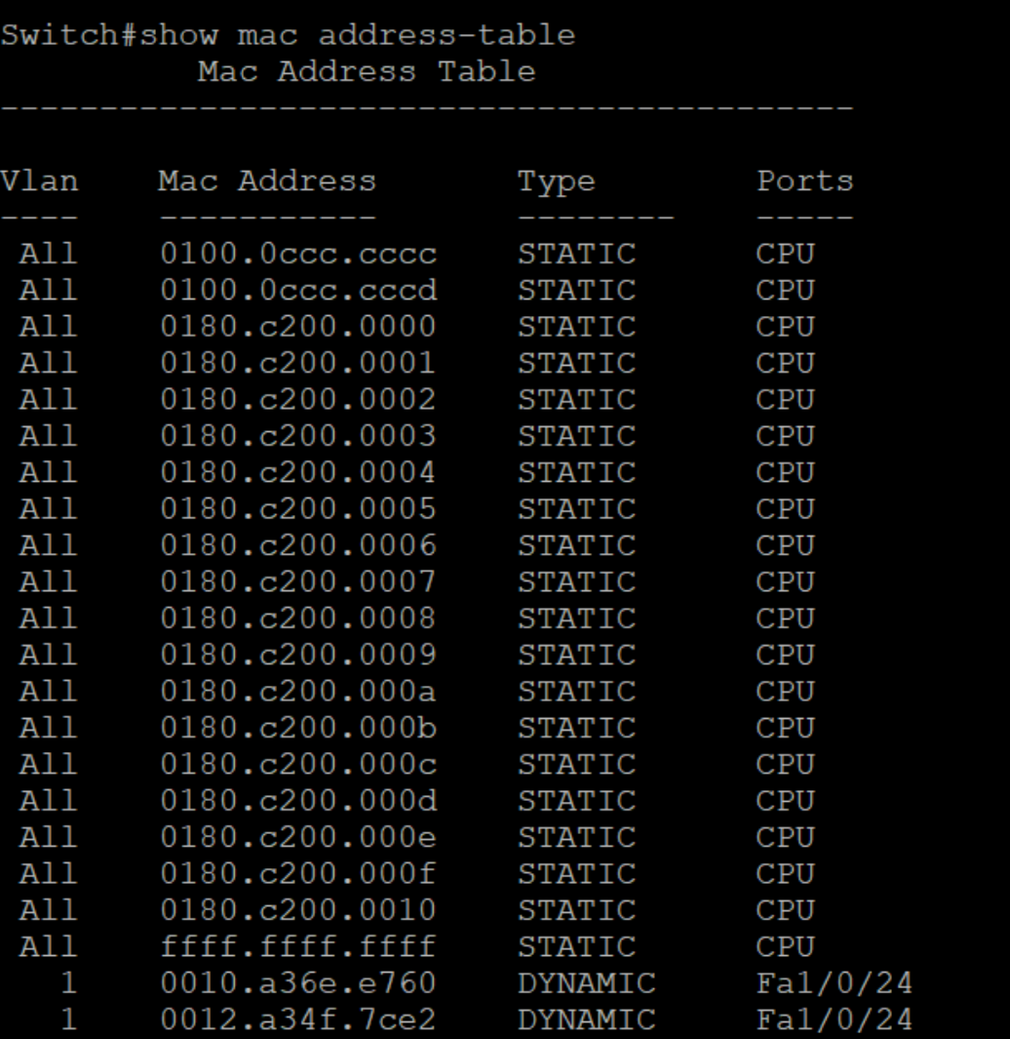

Congratulations, you have fortified your switch in defending against MAC flooding attacks!

Problems:

Our first problem was trying to download Kali Linux. Being unfamiliar with this new operating system, we were struggling with the installation with all the dependencies regarding ISO images and Rufus. After the installations, we were struggling with setting up the environment, spending time trying to optimize the environment via commands but saw no change. We soon realized that Kali Linux was already preinstalled with a lot of preexisting tools like Ettercap and Wireshark.

Our second problem arose when we were trying to run Ettercap on Windows, which was mostly unstable because Ettercap is built to support Linux operating systems. Therefore, to fix this, we installed the Kali Linux setup on our computers to run Ettercap. Alternatively for future projects, we will opt to use virtual machines via VirtualBox or VMware to simulate Kali Linux to keep our Windows configuration.

Our third problem arose when Kali Linux kept crashing. In its setup form, it only contains Cybersecurity resources, but not performance dependencies. This was fixed by downloading driver dependencies and doing our Ettercap operations fast before any crashes happen, which is another reason why we should opt for virtual machines in the future instead.

Conclusion:

To practice Cybersecurity fundamentals, one must indulge in experimenting with running attacks and trying to fortify against those attacks. However, it’s equally as important to utilize powerful tools like Ettercap for the right purpose, which is to safely and responsibly use these tools to do the right things, as one said, “With great power comes great responsibility.”

